

Master Thesis

ROADS, OIL AND LOCAL ECONOMIC ACTIVITY
IN AZERBAIJAN

Elvin Mammadov
Date of birth: 9 October 2002 in Shamkir, Azerbaijan
Matriculation number: 5193022

For earning the degree
Master of Science (M.Sc.)

Supervisor
Marta Bernardi

Supervising professors
Prof. Dr. Christian Leßmann
Prof. Dr. Stefan Eichler

Submission date: 5 October 2026

Abstract
This thesis examines whether the relationship between international oil-price fluctuations and local economic activity differs across space in Azerbaijan. Local economic activity is measured using pixel-level nighttime light intensity from 2013 to 2020, while changes in external oil-market conditions are captured by the real Brent crude oil price. The empirical strategy combines annual variation in oil prices with cross-sectional variation in geographical distance from Baku, the country’s main economic center. District and year fixed effects are included, and standard errors are clustered at the district level.
The results show a negative and statistically significant interaction between the real Brent oil price and distance from Baku. This indicates that periods of higher oil prices are associated with relatively stronger nighttime-light outcomes in locations closer to Baku and weaker outcomes in more distant locations. The relationship remains negative after controlling for distance to the nearest city and major road. Additional robustness checks, including an alternative settlement-based specification and the exclusion of pixels located within Baku, produce a similar spatial pattern.
Overall, the findings suggest that the relationship between oil-related economic conditions and local economic activity is spatially uneven within Azerbaijan. The results highlight the importance of geographical proximity to Baku when examining how aggregate oil-price fluctuations are reflected across different parts of the country.

Table of Contents
Abstract I
Table of Contents II
List of Tables IV
List of Figures V
Abbreviations VI
1 Introduction 1
2 Institutional Background and Related Literature 4
2.1 Oil Dependence and Regional Development in Azerbaijan 4
2.2 Infrastructure and Local Economic Activity 8
2.3 Nighttime Lights as a Measure of Economic Activity 11
2.4 Related Empirical Literature 13
3 Data 17
3.1 Nighttime Lights Data 17
3.2 Road Network Data 20
3.3 Oil Price Data 23
3.4 Administrative Settlement Data 24
3.5 Administrative Boundary Data 26
3.6 Construction of the Analysis Sample 27
3.7 Descriptive Statistics 28
4 Empirical Methodology 30
4.1 Empirical Strategy and Baseline Specification 30
4.2 Fixed Effects, Identification and Inference 31
4.3 Extended Specification and Spatial Controls 32
4.4 Limitations of the Spatial Controls 33
4.5 Robustness Checks 34
5 Empirical Results 37
5.1 Baseline and Extended Results 37
5.2 Robustness Checks 40
5.3 Discussion of the Main Findings 42
6 Conclusion 49
References 52

List of Tables
Table 1. Dynamics of oil exports and GDP in the Republic of Azerbaijan for 2012–2020 4
Table 2. Transfers from SOFAZ to the State Budget and Their Share in Budget Expenditures 5
Table 3: Descriptive Statistics 29
Table 4: Estimation Results 38

List of Figures
Figure 1. Geographic concentration of GDP in Azerbaijan and four other regional countries, share of regions in national GDP 8
Figure 2. Key Oil and Natural Gas Infrastructure in Azerbaijan 10
Figure 3: Maximum Nightlight Intensity of each pixel in Azerbaijan 19
Figure 4: Major and Secondary Road Network in Azerbaijan 22
Figure 5: Administrative Settlements in Azerbaijan 25
Figure 6: Spatial Distribution of Pixels in the Final Analysis Sample 28
Figure 7: Estimated Oil Price × Distance to Baku Interaction Across Specifications 41

Abbreviations
NTL Nighttime Lights
GDP Gross Domestic Product
SOFAZ State Oil Fund of the Republic of Azerbaijan
VIIRS Visible Infrared Imaging Radiometer Suite
OSM OpenStreetMap
USD United States Dollar
FE Fixed Effects

Introduction
In some countries, revenues obtained from resources, especially changes in global commodity prices, have a particular effect on national income and on the public investment of that income across the country in resource-dependent countries, and sometimes these benefits are usually not distributed equally across the country spatially and cause regional inequality. The availability of infrastructure plays an important role in increasing the accessibility of these resource revenues across other regions, and this in turn is one of the factors reducing regional inequality. Usually, however, regions that are close to the main city benefit from these revenues earlier and benefit more compared to distant regions. In countries where economic activity and infrastructure are concentrated around one dominant large city, studying this spatial dimension is particularly important.
Azerbaijan is a suitable example for studying these relationships. The country's economy has historically been closely connected to the oil and gas sector, while Baku and the surrounding Absheron area have served as the country's main economic and administrative centre. Therefore, changes in international oil prices can create significant aggregate economic shocks for the Azerbaijani economy. At the same time, there are significant spatial differences among the regions of Azerbaijan in terms of distance to Baku and access to major transport infrastructure. These characteristics create favourable conditions for investigating the local effects of aggregate oil price changes across space.
This master's thesis investigates whether international oil price shocks are associated with different changes in local economic activity across different areas of Azerbaijan and whether spatial accessibility plays a role in shaping these differences. Local economic activity is measured through the intensity of nighttime lights (NTL). This indicator provides information about economic activity with high spatial precision and allows economic activity to be investigated at smaller geographical units compared to traditional regional economic statistics. In the empirical analysis, satellite-based nighttime lights data are combined with international Brent crude oil prices and geographical distance to Baku. In the extended specification, distance to the nearest city and distance to the nearest major road are included as additional spatial controls.
The empirical strategy uses the interaction between the variation in international Brent oil prices over time and the spatial variation in distance to Baku. The analysis does not rely only on oil price changes that are the same for all areas of Azerbaijan in a particular year. Instead, it investigates whether areas located at different distances from the country's main economic centre react differently to the same aggregate oil price shock. District and year fixed effects (FE) are used to account for time-invariant district characteristics and common annual shocks affecting the entire country. Standard errors are clustered at the district level to account for potential dependence among observations within the same administrative district. Road accessibility constitutes an additional spatial dimension of the analysis. Proximity to major transport infrastructure can determine the extent to which areas are connected to markets and economic centres and can thereby affect local economic activity. However, road infrastructure also creates an important empirical problem. Roads constructed during the study period may themselves be the result of economic conditions and investments financed by oil revenues. Including such infrastructure in the model as a control variable may cause a post-treatment bias problem. Therefore, the specification without these additional spatial controls remains the baseline model, while road and city accessibility are introduced in the extended specification. Since complete historical road data are not available, these spatial controls are treated as time-invariant characteristics and are not given a direct causal interpretation.
The Brent oil price is used in real terms in the empirical analysis in order to account for changes in the general price level over the study period.
Thus, the master's thesis investigates the following main research question:

How does the relationship between international oil-price fluctuations and local economic activity vary with geographical distance from Baku in Azerbaijan?
This study aims to contribute to the existing literature on natural resources, infrastructure, and spatial economic development in three directions. First, it investigates not only the national but also the local consequences of changes in oil prices in a highly resource-dependent economy. Second, the use of nighttime lights data with high spatial precision makes it possible to analyse heterogeneity within the country that may not be visible in regional aggregate indicators. Third, by combining changes in oil prices with geographical exposure and additional measures of urban and road accessibility, the study provides evidence on the spatial heterogeneity of oil-related economic conditions within Azerbaijan.
The remainder of the master's thesis is structured as follows. Section 2 reviews the relevant literature on natural resources, oil price shocks, transport infrastructure, and the use of nighttime lights in measuring economic activity. Section 3 explains the datasets used and the construction of the main variables. Section 4 explains the empirical strategy. Section 5 presents the main empirical results, robustness analyses, and discussion of the findings. Section 6 concludes the thesis.

Institutional Background and Related Literature

Oil Dependence and Regional Development in Azerbaijan
Azerbaijan represents a relevant case for examining the relationship between natural resource dependence and regional economic development. The country's economic development has been strongly influenced by its oil and gas sector, with hydrocarbon exports accounting for a substantial share of total exports. Table 1 shows the statistics about oil exports and GDP in the Republic of Azerbaijan for 2012–2020.

Table 1. Dynamics of oil exports and GDP in the Republic of Azerbaijan for 2012–2020
Year | 2012 | 2013 | 2014 | 2015 | 2016 | 2017 | 2018 | 2019 | 2020
Oil exports per capita  [US dollars] | 2,410.3 | 2,375.9 | 2,129 | 1,166.2 | 819.7 | 1,413.6 | 1,805.9 | 1,783.3 | 1,190.1
GDP per capita  [US dollars] | 7,594.3 | 7,977.4 | 7,990.8 | 5,561.5 | 3,928.6 | 4,198.5 | 4,797.8 | 4,864 | 4,280.8
Share of oil exports in total exports in the country [%] | 93.1 | 92.7 | 92.4 | 87.8 | 87 | 90.5 | 91.9 | 90.6 | 87.2
Source: Author’s compilation based on (Hajiyeva et al., 2025), using data originally obtained from the State Statistics Committee of the Republic of Azerbaijan.

Table 1 highlights the dominant role of oil and petroleum products in Azerbaijan’s export structure. Throughout the period under consideration, oil and petroleum products accounted for approximately 87–93% of the country’s total exports (Hajiyeva et al., 2025), indicating a persistently high dependence on the hydrocarbon sector. Such a high concentration of exports implies that fluctuations in international oil prices can have substantial consequences for export revenues and, consequently, for overall economic activity. Higher oil prices increase the value of oil-related exports and generate additional revenues for the Azerbaijani economy, whereas periods of declining oil prices may significantly reduce these inflows. This strong exposure to global oil market conditions provides an important motivation for examining oil-price fluctuations as a source of variation in economic activity in Azerbaijan. In the context of this study, these fluctuations may also affect local economic activity through changes in public revenues and investment, including infrastructure expenditure, which can ultimately be reflected in nighttime light intensity across regions.
According to the State Oil Fund of the Republic of Azerbaijan (SOFAZ, 2024), SOFAZ is an important institution in the management of Azerbaijan's hydrocarbon revenues. Established in 1999, the Fund was created to accumulate and manage revenues generated from the country's oil and gas resources. It operates as an extra-budgetary institution separate from the government budget and plays an important role in the management of Azerbaijan's resource revenues. Transfers from SOFAZ to the state budget represent an important fiscal channel through which Azerbaijan's hydrocarbon revenues enter public finances. Once transferred to the state budget, these resources contribute to the government's overall financing capacity, including its ability to finance public investment and infrastructure expenditures. Hydrocarbon export revenues go to the budget of SOFAZ. Then, each year, transfers are made from SOFAZ to the state budget, and the share of these transfers in the state budget is very high. However, a decline in this share can be observed in recent years. Table 2 presents the annual transfers from SOFAZ to the State Budget of Azerbaijan and their share in total budget expenditures over the period 2007–2025.

Table 2. Transfers from SOFAZ to the State Budget and Their Share in Budget Expenditures
Year | Budget expenditures (mln. AZN) | Transfers from SOFAZ (mln. AZN) | SOFAZ transfer share in budget expenditures (%)
2007 | 6,086.2 | 585.0 | 9.6
2008 | 10,774.2 | 3,800.0 | 35.3
2009 | 10,503.8 | 4,915.0 | 46.8
2010 | 11,655.9 | 5,915.0 | 50.8
2011 | 15,397.5 | 9,000.0 | 58.5
2012 | 17,416.5 | 9,905.0 | 56.9
2013 | 19,143.5 | 11,350.0 | 59.3
2014 | 18,709.0 | 9,337.0 | 49.9
2015 | 21,100.0 | 8,130.0 | 38.5
2016 | 17,751.2 | 7,615.0 | 42.9
2017 | 17,594.7 | 6,100.0 | 34.7
2018 | 22,731.6 | 10,959.0 | 48.2
2019 | 24,425.9 | 11,363.3 | 46.5
2020 | 26,416.3 | 12,200.0 | 46.2
2021 | 27,422.4 | 12,200.0 | 44.5
2022 | 32,064.6 | 7,923.0 | 24.7
2023 | 36,457.9 | 11,737.6 | 32.2
2024 | 37,713.6 | 12,781.0 | 33.9
2025 | 38,603.6 | 14,481.0 | 37.5
Source: Adapted from Ibadoghlu (2026).

As shown in the table 2, transfers from the State Oil Fund of the Republic of Azerbaijan (SOFAZ) to the state budget accounted for a substantial share of total budget expenditures between 2009 and 2021, with this share remaining around 50 percent in several years. These figures indicate that, particularly during the 2010–2020 period, Azerbaijan’s public finances were strongly dependent on revenues originating from the oil sector. Consequently, fluctuations in international oil prices may have had important implications for government revenues and expenditures during this period.
After 2021, however, the share of SOFAZ transfers in total budget expenditures declined noticeably. This development may partly reflect the increasing importance of the non-oil sector and the effects of government programs aimed at economic diversification, although this interpretation would require further evidence. For the purpose of this thesis, the particularly important observation is the strong dependence on oil revenues during the 2010–2020 period. This provides additional motivation for the empirical analysis by suggesting a potential channel through which changes in international oil prices can affect economic activity in Azerbaijan. The thesis therefore investigates whether fluctuations in oil prices are reflected in local economic activity across the country, using nighttime light data as a spatial proxy for economic activity.
Azerbaijan is one of the post-Soviet countries with high regional inequality and has the highest level of regional inequality in the South Caucasus. Official government statistics provide few precise indicators of regional GDP, which further motivates using nighttime lights data to highlight inequalities across regions. This approach also makes it possible to examine the outcomes of government programs and investments aimed at regional development between 2010 and 2020. Figure 1 presents a histogram illustrating the geographic concentration of GDP in Azerbaijan and four other regional countries, based on data for 2023. For each country, the figure shows the region with the highest share of national GDP, the region with the second-highest share, and the region with the lowest share. Azerbaijan and its neighbouring countries are included in the comparison. According to these indicators, Azerbaijan has the largest difference between the regions with the highest and lowest shares of national GDP among the countries presented. Moreover, 76.1% of Azerbaijan’s GDP is concentrated in a single region, namely the capital, Baku. This high degree of economic concentration highlights the extent of regional inequality within the country. In this context, reducing regional disparities has also been one of the government’s priorities in promoting more balanced regional development. Against this background, this thesis examines how proximity to roads, changes in international oil prices, and distance from Baku are associated with local economic activity across Azerbaijan.

Figure 1. Geographic concentration of GDP in Azerbaijan and four other regional countries, share of regions in national GDP
Source: Baku Research Institute (2025)

Infrastructure and Local Economic Activity
Transport infrastructure improves the transfer of economic activity across the regions by determining the costs of connecting locations to markets. Improved road access can minimize transportation costs, facilitate the movement of goods and people, and strengthen access to larger markets. Lower transport costs may allow firms to obtain inputs at lower prices and sell their products to more consumers, while also improving the economic integration of relatively remote locations. Consequently, locations with better transport connections may face more favorable conditions for investment, production, and trade than geographically isolated areas (Storeygard, 2016).
Storeygard (2016) provides empirical evidence on how transport costs and road accessibility affect secondary cities depending on their distance from the main port city. He uses nighttime light data as a proxy for city-level economic activity and exploits variation in road-network distance and changes in world oil prices to generate variation in transport costs. The results show that when oil prices increase, cities located farther from the main port city experience lower economic growth, while cities located closer to the main port experience relatively stronger growth. This growth is measured using changes in nighttime light intensity. According to Storeygard's estimates, an increase in the oil price from USD 25 to USD 97 is associated with approximately 7 percent lower income for a city located 500 km farther from the main port (Storeygard, 2016, pp. 1263–1264).
Azerbaijan provides a suitable setting for a similar spatial analysis because its main city, Baku, is simultaneously the capital, a port city on the Caspian Sea, and the country's largest center of economic activity compared with other cities. As discussed previously, Azerbaijan is also highly dependent on oil revenues. Fluctuations in international oil prices can therefore affect the resources available to the government. The oil boom has also supported high levels of public investment (World Bank, 2022, p. 5). This mechanism is particularly relevant for Azerbaijan, where economic activity and public finances have historically been strongly influenced by oil revenues. Economic activity is also highly concentrated in Baku, with the capital accounting for almost 76% of total GDP according to Baku Research Institute (2025).
Differences in geographical accessibility may influence how oil-related economic conditions are reflected across regions. These characteristics provide a motivation for investigating whether the relationship between oil-price fluctuations and local economic activity varies systematically with geographical distance from Baku. Building on the spatial intuition of Storeygard (2016), the empirical analysis interacts the real Brent oil price with log distance from Baku to examine whether this relationship differs across space. Nighttime lights are used as a proxy for local economic activity. However, the economic mechanism differs from that in Storeygard (2016). In Azerbaijan, higher international oil prices may improve national oil revenues and broader economic conditions rather than operating primarily through higher transportation costs.
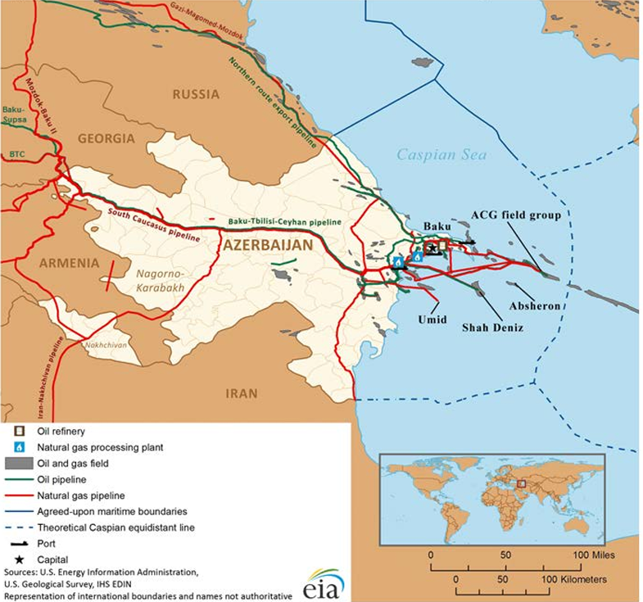
Figure 2. Key Oil and Natural Gas Infrastructure in Azerbaijan
Source: U.S. Energy Information Administration (2019, p.7)
Figure 2 illustrates the spatial distribution of Azerbaijan's major oil and gas fields and related energy infrastructure. As shown in the figure, the major oil and gas fields are largely concentrated offshore in the Caspian Sea, particularly to the east of Baku and the Absheron Peninsula (U.S. Energy Information Administration, 2019). Although the main production fields are located offshore. This spatial structure is relevant for the present analysis, which investigates whether the effects of oil-price fluctuations on local economic activity vary with geographical distance from Baku. At the same time, economic activity is strongly concentrated in Baku, which accounted for 64.6 percent of Azerbaijan's economic output in 2020 (World Bank, 2022, p. 21).

Nighttime Lights as a Measure of Economic Activity
GDP statistics are available at the national level and are widely used as a traditional measure of economic activity. However, for smaller geographical areas or specific regions within a country, and particularly at the city level, GDP data are often unavailable. In addition, there are concerns regarding the accuracy of these data in developing countries. Henderson et al. (2012, pp. 994–997) emphasize that GDP data may be subject to serious measurement errors when they are incorrectly measured or produced by weak statistical institutions, and this problem is particularly common in developing countries. Nighttime light data provide an alternative approach to overcoming these limitations and offer a spatially detailed measure that can be used as a proxy for local economic activity.
The economic interpretation of nighttime lights is based on the relationship between artificial illumination and human economic activity. Economic activities such as consumption, production, transportation, commercial services, and infrastructure use are generally associated with the use of electricity and artificial lighting. Consequently, areas with higher population concentrations and higher levels of economic activity tend to emit more observable light at night. Henderson et al. (2012, pp. 999–1001) explain that nighttime illumination reflects both outdoor and, to some extent, indoor lighting, and that the use of lighting generally increases with income and economic activity. The authors' comparison of nighttime illumination across countries and regions also shows that areas with higher levels of economic activity generally exhibit greater observed light intensity. Thus, the authors establish a systematic relationship between changes in nighttime lights and changes in economic activity.
Henderson et al. (2012, pp. 996–997) note that satellite observations allow economic activity to be examined at considerably smaller geographical scales than is possible using traditional national accounts. The spatial resolution of nighttime light data varies across datasets. The DMSP-OLS data used by Henderson et al. (2012, pp. 996–998) have a spatial resolution of approximately 1 km. In addition, satellite observations are collected using the same measurement technology across different geographical areas, allowing researchers to construct spatially comparable indicators that are not restricted by administrative reporting boundaries. These characteristics make nighttime lights particularly useful for investigating the geographical distribution of economic activity and the effects of economic shocks at the local level.
The usefulness of nighttime lights is not limited to capturing differences in the level of economic activity. Changes in light intensity can also reflect changes in economic conditions over time. Henderson et al. (2012, pp. 996, 1001–1003) provide several examples demonstrating this relationship. For instance, the substantial increase in economic activity in South Korea between 1992 and 2008 was accompanied by a considerable expansion in nighttime illumination. Conversely, during the Asian financial crisis, Indonesia experienced both a decline in real GDP and a decline in observed nighttime lights. These examples show that nighttime lights can respond not only to long-term economic development but also to relatively short-term economic fluctuations.
Nevertheless, nighttime light intensity should not be interpreted as a direct measure of GDP. The relationship between observed luminosity and economic activity may vary due to differences in population density, the composition of production, patterns of electricity use, and the relative importance of economic activities taking place during the day and at night. Satellite measurements may also be affected by technical factors such as sensor characteristics and saturation in highly illuminated locations. Henderson et al. (2012, pp. 999–1000) therefore emphasize that differences in raw nighttime light values across locations should be interpreted carefully. These limitations are particularly relevant when comparing absolute levels of economic activity across heterogeneous geographical areas. However, panel observations of nighttime lights over time, combined with fixed effects, can help account for persistent geographical and structural differences between locations. For the purposes of this thesis, these characteristics make nighttime lights particularly suitable for examining local economic activity in Azerbaijan. Aggregate national or regional economic statistics provide only limited information about how economic activity is distributed within administrative regions. In contrast, spatially disaggregated nighttime light observations make it possible to examine variation in economic activity both across locations and over time. This is particularly important for the present analysis, which investigates whether the relationship between international oil-price fluctuations and local economic activity varies geographically with distance from Baku. Nighttime lights therefore provide a useful outcome variable for identifying spatial differences in local economic responses that may remain hidden in aggregate economic indicators.

Related Empirical Literature
Donaldson (2018) provides important empirical evidence on the relationship between transport infrastructure and local economic outcomes by examining the expansion of the railway network in colonial India. Using district-level panel data, he finds that railroad expansion substantially reduced trade costs and increased interregional trade (Donaldson, 2018, pp. 916–924). Importantly, gaining access to the railroad network increased real agricultural income by approximately 16 percent (Donaldson, 2018, pp. 923–924). The analysis further indicates that slightly more than half of the estimated income effect can be explained by reduced trade costs and increased opportunities for trade (Donaldson, 2018, pp. 930–931). These findings demonstrate how improvements in transport connectivity can translate into higher local economic activity through better market access.
Nighttime lights have also become an established proxy for measuring spatial economic activity, particularly where conventional economic statistics are limited. Henderson et al. (2012, pp. 994–996) demonstrate that satellite-recorded nighttime lights contain valuable information about economic activity and can complement conventional income measures, particularly in settings where official statistics are of lower quality. Building on this approach, Storeygard (2016) uses nighttime lights to measure changes in economic activity across African cities and to identify spatially heterogeneous responses to changes in transport costs. Together, these studies provide empirical support for the use of nighttime lights as a spatially disaggregated measure of local economic activity, which is particularly suitable for examining heterogeneous local responses to infrastructure and economic shocks.
Caselli and Michaels (2013) examine how oil-related fiscal windfalls affect local economic conditions using variation in oil production across Brazilian municipalities. They show that oil production generates substantial additional revenues for local governments, which is accompanied by higher reported expenditure in areas such as urban development, education, health, and transportation. However, these increases in public spending are not matched by similarly large improvements in infrastructure, public services, or household income. Their findings therefore suggest that resource windfalls can substantially expand local fiscal resources without necessarily producing proportional improvements in local living standards. This highlights the fiscal channel as an important mechanism through which oil-sector shocks may influence regional economic outcomes.
More directly related to the spatial dimension of resource shocks, Ishak and Méon (2023) examine how changes in oil and gas revenues affect economic activity across Brazilian municipalities. They exploit fluctuations in international oil and gas prices, combined with initial local production levels, to isolate variation in resource revenues that is plausibly unrelated to local economic conditions (Ishak & Méon, 2023). Using nighttime lights as their main measure of economic activity, they find that higher resource revenues benefit oil-producing municipalities, while the effects on surrounding areas are substantially less favorable. In particular, a 10 percent increase in oil and gas revenues is associated with approximately 1.4 percent higher economic activity in producing municipalities, whereas neighboring municipalities experience negative spillover effects (Ishak & Méon, 2023). The results therefore show that the local consequences of resource windfalls can vary considerably across space and may be obscured when economic activity is examined only at a more aggregated geographical level (Ishak & Méon, 2023).
Although the empirical approach of this thesis is motivated by Storeygard (2016), the underlying economic mechanism differs. In Storeygard’s setting, increases in oil prices raise transportation costs, placing cities that are farther from major ports at a relative disadvantage. In Azerbaijan, by contrast, higher oil prices represent a positive external shock for an oil-exporting economy by increasing the value of the country’s main export revenues. This thesis therefore examines whether the local economic effects associated with oil-price fluctuations are distributed unevenly across space, particularly according to distance from Baku. In this way, the analysis adapts Storeygard’s spatial identification logic to a different transmission mechanism and country context. Taken together, the existing literature highlights the importance of transport accessibility for local economic outcomes, establishes nighttime lights as a useful measure of economic activity at fine spatial scales, and shows that resource-related shocks can have uneven effects across locations. However, less is known about how international oil-price fluctuations are transmitted spatially within an oil-exporting economy and whether their local effects vary with geographical distance from the country’s main economic center. This thesis addresses this gap in the context of Azerbaijan by examining whether the relationship between international oil-price fluctuations and local economic activity varies systematically with distance from Baku. Using spatially disaggregated nighttime light data, the analysis provides evidence on the geographic distribution of economic responses to oil-price fluctuations within a highly oil-dependent economy.

Data
The empirical analysis combines several data sources to examine the spatial relationship between international oil-price fluctuations and local economic activity in Azerbaijan. Nighttime light data are used as the main measure of local economic activity, while spatial road-network and settlement data provide information on local accessibility. International oil prices capture external fluctuations in oil-market conditions, and administrative boundary data are used to assign pixels to districts and construct a consistent geographical sample.

Nighttime Lights Data
The main measure of local economic activity used in this thesis is nighttime light intensity obtained from satellite observations. The analysis uses VIIRS nighttime light data for the period from 2013 to 2020.
The choice of the 2013–2020 period allows the analysis to rely on a consistent nighttime light data source throughout the entire sample. This avoids combining observations from the DMSP and VIIRS satellite systems, which differ substantially in their spatial resolution, range of luminosity values, and sensor quality (Chiovelli et al., 2026, p. 5). Using VIIRS throughout the analysis period therefore avoids the need to harmonize observations from the two satellite systems. The selected period also contains considerable variation in international oil prices, which is important for the empirical analysis described in Chapter 4.
For the empirical analysis, the nighttime light observations are restricted to the geographical territory of Azerbaijan. The annual raster files are processed using a common spatial grid so that the same geographical locations can be followed over time. Each raster cell is assigned a unique pixel identifier, which makes it possible to construct a pixel-level panel covering the years 2013–2020. The resulting structure therefore provides repeated annual observations of nighttime light intensity for the same locations across Azerbaijan.
The spatially disaggregated structure of the VIIRS data is particularly useful for the purpose of this thesis because economic activity can be observed at a much finer geographical level than conventional regional economic statistics. Rather than assigning a single measure of economic activity to an entire administrative district, the nighttime light data allow variation within districts to be observed. This makes it possible to construct a detailed spatial panel and to examine variation in local economic activity across locations and over time according to their geographical characteristics. The resulting log-transformed nighttime light intensity is therefore used as the main dependent variable in the empirical analysis.
The nighttime light data used in this analysis are based on the V.2 annual VIIRS nighttime light products developed by Elvidge et al. (2021). More specifically, the analysis uses the masked average radiance product, in which background areas, biomass burning, and aurora are identified through the filtering procedure and set to zero (Elvidge et al., 2021, p. 8). The annual VIIRS products are constructed from monthly cloud-free radiance observations collected by the VIIRS Day/Night Band (DNB) and are provided on a 15-arc-second spatial grid, which is approximately 500 m resolution (Elvidge et al., 2021, pp. 1–2). Radiance is measured in $nW/cm²/sr$. The use of the masked product reduces the influence of background noise and temporary light sources that do not represent persistent surface lighting (Google Earth Engine, n.d.).
For the empirical analysis, the annual nighttime light rasters are restricted to the geographical boundaries of Azerbaijan and organized on a common spatial grid. Each grid cell is assigned a unique pixel identifier, allowing the same geographical locations to be followed over time. The resulting dataset therefore has a pixel-year panel structure covering the period from 2013 to 2020.
To construct the spatial sample used in the empirical analysis, the annual VIIRS rasters were first aligned to a common grid. Pixels satisfying the sample-selection criterion were retained and subsequently followed over the full 2013–2020 period. This procedure creates a consistent set of spatial units and prevents changes in the composition of the sample across years from being mechanically interpreted as changes in local economic activity.
Each retained pixel was spatially assigned to an administrative district using the administrative boundaries of Azerbaijan. This spatial matching provides a district identifier for each pixel while preserving the underlying pixel-level nighttime light observations. Consequently, the empirical dataset retains within-district spatial variation in nighttime light intensity while also allowing pixels to be grouped according to their administrative location. This district classification is subsequently used in the fixed-effects specifications and for clustering standard errors at the district level.
A further spatial restriction is applied to the sample by excluding the conflict-affected districts specified in the data-cleaning procedure. The same geographical exclusion is applied consistently across the spatial datasets used in the analysis. This ensures that nighttime light observations and the other spatial variables are constructed over a common geographical sample.
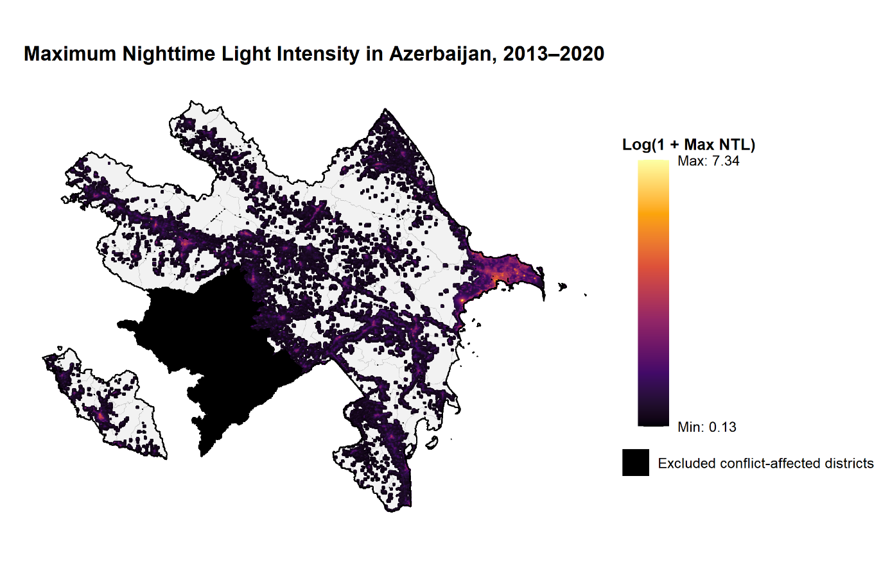
Figure 3: Maximum Nightlight Intensity of each pixel in Azerbaijan
Source: Author's calculations based on VIIRS nighttime light data.
Figure 3 presents the spatial distribution of nighttime light observations included in the final empirical sample. To construct the spatial sample, a persistence criterion is applied to distinguish repeatedly illuminated locations from pixels showing only occasional positive nighttime light observations. For each pixel, the number of years with positive nighttime light intensity ($NTL>0$) is calculated over the 2013–2020 period. A pixel is retained in the sample if positive nighttime light intensity is observed in at least three years. Thus, no additional minimum radiance threshold is imposed beyond $NTL>0$; the selection criterion is based primarily on the persistence of observed nighttime lighting over time.
The figure displays all pixels remaining in the final dataset after the pixel-selection, geographical restriction, and data-cleaning procedures. For visualization, the maximum nighttime light intensity recorded for each retained pixel during the 2013–2020 period is calculated and transformed as $\ln{⁡}\left(1+\text{maximum} \text{NTL}\right).$The colour scale therefore represents the maximum nighttime light intensity observed at each location over the sample period, with higher values indicating greater maximum radiance. Areas shown in black represent conflict-affected districts excluded from the empirical sample. The retained pixels form the spatial units of the final dataset and are followed annually from 2013 to 2020, resulting in the pixel-year panel used in the empirical analysis.

Road Network Data
Road network data for Azerbaijan are obtained from OpenStreetMap (OpenStreetMap contributors, 2026) through an export provided by the Humanitarian OpenStreetMap Team (HOT). The dataset provides georeferenced road segments across Azerbaijan together with the OSM highway classification, which makes it possible to distinguish roads according to their functional importance. The road data are used to construct measures of road accessibility for the nighttime light pixels included in the empirical sample.
Since the original OSM data contain a large number of individual road types, the road segments are grouped into broader categories for the analysis. Roads classified by OSM as motorway, trunk, or primary are grouped as major roads, representing the main components of the road network. Roads classified as secondary or tertiary are grouped as secondary roads. In addition, residential, living_street, service, and unclassified roads are categorized as local roads, while track, path, and footway are classified separately as minor non-road routes. Distances to both major and secondary roads are calculated during data construction. In the final extended specification, distance to the nearest major road is used as the main road-accessibility control in order to keep the specification parsimonious.
To calculate road accessibility, both the nighttime light pixels and the road network are projected to the WGS 84 / UTM Zone 39N (EPSG:32639) coordinate reference system. For every pixel retained in the final nighttime light sample, the shortest distance to the nearest major road and the nearest secondary road is calculated in meters. Thus, each pixel is assigned two time-invariant accessibility measures: distance to the nearest major road and distance to the nearest secondary road. Because the road network is treated as fixed over the 2013–2020 study period, these distance measures do not vary over time within a pixel.
For the empirical specification, distance to the nearest major road is transformed as $ln\left(1+d\right)$, where $d$ denotes the distance in meters to the nearest major road. Accordingly, the variable used in the analysis is $ln\left(1+\text{distance to major road}\right)$. The addition of one allows the logarithmic transformation to be defined for pixels located directly on, or extremely close to a road. This variable is subsequently used as a spatial control in the extended empirical specification.
An important limitation of the road network data is its lack of consistent historical information. The OpenStreetMap extract represents the road network observed in the available dataset, while information on the year in which individual road segments were constructed or opened to traffic is generally not available in a sufficiently systematic form. It is therefore not possible to reconstruct a separate road network for each year between 2013 and 2020. Consequently, the road network is treated as time-invariant throughout the study period, and the calculated distances to major roads are assigned as fixed spatial characteristics of each pixel. This implies that the analysis does not capture changes in road accessibility resulting from roads constructed or upgraded during the sample period. The road-distance variables should therefore be interpreted as measures of spatial accessibility based on the observed road network rather than as year-specific measures of historical road access.
Distances to major and secondary roads are calculated separately because different categories of the road network may represent different dimensions of local transport accessibility.
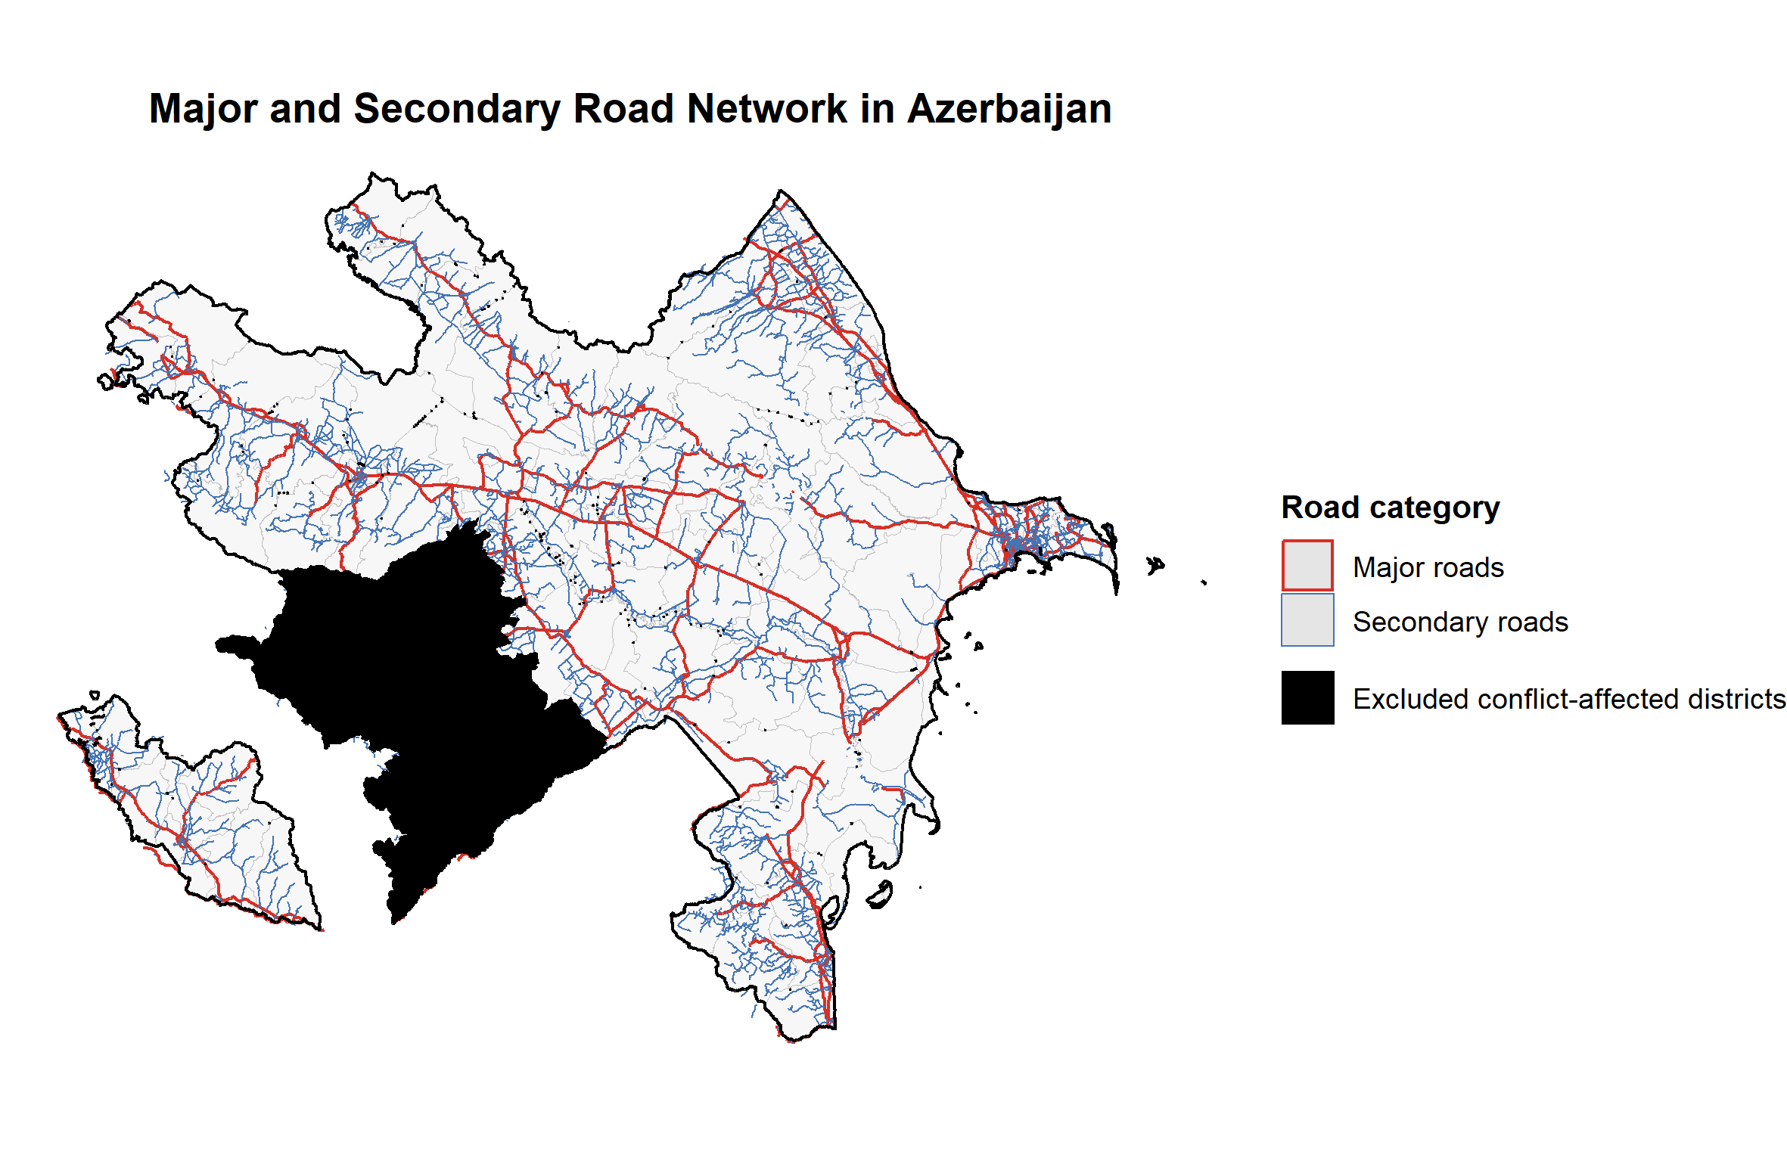
Figure 4: Major and Secondary Road Network in Azerbaijan
Source: Author’s own illustration based on OpenStreetMap data obtained through the Humanitarian OpenStreetMap Team (HOT)
Figure 4 presents the spatial distribution of major and secondary roads across Azerbaijan. Major roads are shown in red, while secondary roads are shown in blue. The black areas represent conflict-affected districts excluded from the empirical analysis. The figure illustrates the road network used to construct the pixel-level measures of distance to major and secondary roads. But in the empirical analysis only distance to major roads is used.

Oil Price Data
International oil price data are obtained from the World Bank Commodity Price Data (The Pink Sheet). The dataset provides historical commodity prices for a broad range of internationally traded commodities, including crude oil. This thesis uses the annual price of Brent crude oil for the period from 2013 to 2020, corresponding to the temporal coverage of the nighttime lights data. Since the oil-price variable is common to all locations within Azerbaijan in a given year, its variation occurs exclusively over time.
The dataset provides both nominal and constant-price measures. The main empirical analysis uses the real Brent crude oil price, while the nominal series is retained for descriptive purposes. In the World Bank dataset, constant commodity prices are obtained by deflating nominal prices using the Manufactures Unit Value (MUV) index. The MUV index measures the unit value of manufactured exports from a group of major economies, with 2010 used as the reference year. Using the real oil-price series accounts for changes in the general price level and allows oil-price movements over the study period to be expressed in constant terms. Brent crude oil prices are expressed in U.S. dollars per barrel and are observed at an annual frequency.
Over the sample period, Brent prices exhibit substantial variation. The real Brent price declined markedly between 2013 and 2016, subsequently recovered, and fell again in 2020. This temporal variation provides the external oil-price variation used in the empirical analysis. Given Azerbaijan's importance as an oil-exporting economy, fluctuations in international oil prices provide a measure of changes in external oil-market conditions faced by the country.
In the empirical analysis, the real Brent oil price is combined with the time-invariant distance-to-Baku measure to construct the main oil-price–distance interaction variable. Further details on the construction and interpretation of this interaction are provided in the empirical methodology section.

Administrative Settlement Data
Data on administrative settlements are obtained from the IDDA Open Data Portal. The dataset, entitled Cities and Administrative Territorial Units of Azerbaijan, is provided by the Digital Ecology Information System (REİS) and contains information on settlements and their geographical coordinates. The data are provided in GeoJSON format and distinguish between different types of settlements, including cities, settlements, and villages. Each settlement is represented by a geographical point and is accompanied by information on its settlement type and corresponding administrative district (REİS, 2025).
The settlement data are combined with the nighttime light data to construct measures of local settlement characteristics. For each nighttime light pixel, the nearest city is identified and the straight-line distance between the pixel and that city is calculated. In addition, the nearest administrative settlement is identified in order to determine its settlement type. Both the settlement locations and nighttime light pixels are projected to the WGS 84 / UTM Zone 39N (EPSG:32639) coordinate reference system. The distance to the nearest city is measured in meters and transformed as $ln\left(1+d\right)$, where $d$ denotes the distance in meters to the nearest city. After applying the geographical exclusions used in the empirical analysis, the final settlement dataset contains 3,546 locations, comprising 3,265 villages, 216 towns and 65 cities. In the main extended specification, the distance to the nearest city is used as the settlement-related spatial control, while the type of the nearest administrative settlement is used separately in the robustness analysis as an alternative measure of local settlement characteristics.
Nighttime light intensity may be systematically related to proximity to larger urban centers, as pixels located closer to cities are likely to be more strongly connected to population concentrations, services, and economic activity. Including this measure therefore helps account for spatial differences in urban proximity when estimating the relationship between oil-price fluctuations, distance from Baku, and nighttime light intensity. The type of the nearest settlement is used separately in the robustness analysis as an alternative way of capturing local settlement characteristics.
An important limitation of the settlement data is that settlements are represented as geographical points rather than as spatial boundaries of built-up areas. Consequently, the distance-to-city measure captures the distance from each nighttime light pixel to the geographical point representing the nearest city, rather than to the actual physical boundary of the urban area. In addition, the settlement type assigned to each pixel in the robustness analysis refers only to the type of its nearest settlement and should not be interpreted as a direct classification of the pixel itself as urban or rural.

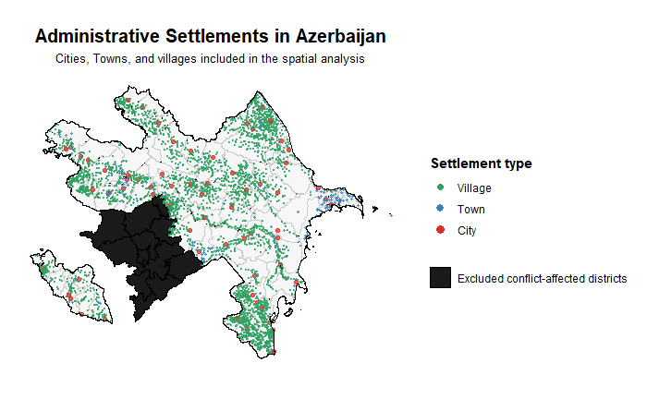
Figure 5: Administrative Settlements in Azerbaijan
Source: Author’s own illustration based on data from the Digital Ecology Information System (REİS), obtained through the IDDA Open Data Portal (2025)
Figure 5 shows the spatial distribution of administrative settlements included in the analysis. The dataset distinguishes between villages, towns, and cities, represented by green, blue, and red points, respectively. Black areas indicate conflict-affected districts excluded from the empirical sample. The settlement locations are used to identify the nearest city for each nighttime light pixel and to determine the type of the nearest administrative settlement used in the robustness analysis.

Administrative Boundary Data
Administrative boundary data are obtained from the IDDA Open Data Portal. The dataset, entitled Regions of Azerbaijan, is provided by the Digital Ecology Information System (REİS) and contains geographical information on the administrative districts of Azerbaijan. The data are provided in GeoJSON format and are used to define the administrative boundaries applied throughout the spatial analysis (REİS, 2025).
The administrative boundary data provide the geographical framework for assigning nighttime light pixels to their corresponding administrative districts. Each nighttime light pixel is spatially matched to the administrative polygon in which it is located, thereby assigning a district identifier to the pixel. This allows the pixel-level nighttime light observations to be organized according to administrative units and provides the district classification used in the empirical analysis.
The boundary data are also used to maintain a consistent geographical sample across the different spatial datasets. Conflict-affected districts excluded from the empirical analysis are identified using their administrative boundaries, and the same geographical exclusions are applied consistently to the nighttime light, road, and settlement datasets. The administrative boundaries are additionally used in the descriptive maps to display district borders and to identify the areas excluded from the final empirical sample.
For spatial operations requiring distances in metric units, the administrative boundary data are transformed from WGS 84 (EPSG:4326) to WGS 84 / UTM Zone 39N (EPSG:32639) where necessary. This ensures consistency with the coordinate reference system used for the calculation of spatial distances in the analysis.

Construction of the Analysis Sample
The datasets described above are combined to construct the final pixel-year dataset used in the empirical analysis. The nighttime light grid constitutes the spatial basis of the panel, with each retained pixel representing a fixed geographical location observed annually between 2013 and 2020. The sample is restricted to pixels satisfying the persistence criterion and located within the geographical area retained for the analysis, as described in Section 3.1. Spatial information from the road network, settlement, and administrative boundary datasets is then linked to these nighttime light pixels. Each pixel is characterized by its administrative district, distance to Baku, distance to the nearest major road, distance to the nearest city, and the type of its nearest administrative settlement. These geographical characteristics are time-invariant within the sample period. In contrast, nighttime light intensity and the real Brent oil price vary annually.
The resulting dataset therefore combines temporal variation in nighttime light intensity and international oil prices with cross-sectional variation in geographical characteristics. The main dependent variable is the natural logarithm of one plus nighttime light intensity, $ln\left(1+NTL\right)$. Distance to Baku forms the main spatial dimension of the empirical strategy, while distance to the nearest city and major road are used as additional spatial controls in the extended specification. The type of the nearest settlement is used separately in the robustness analysis. This final pixel-year panel forms the basis for the empirical specifications presented in Chapter 4.
Figure 6 shows the spatial distribution of the nighttime light pixels retained in the final analysis sample. The selected pixels are concentrated mainly around urban areas, transport corridors, and other persistently illuminated locations, while the grey areas represent conflict-affected districts excluded from the analysis. Each retained pixel is observed annually over the 2013–2020 period and forms part of the final pixel-year panel.
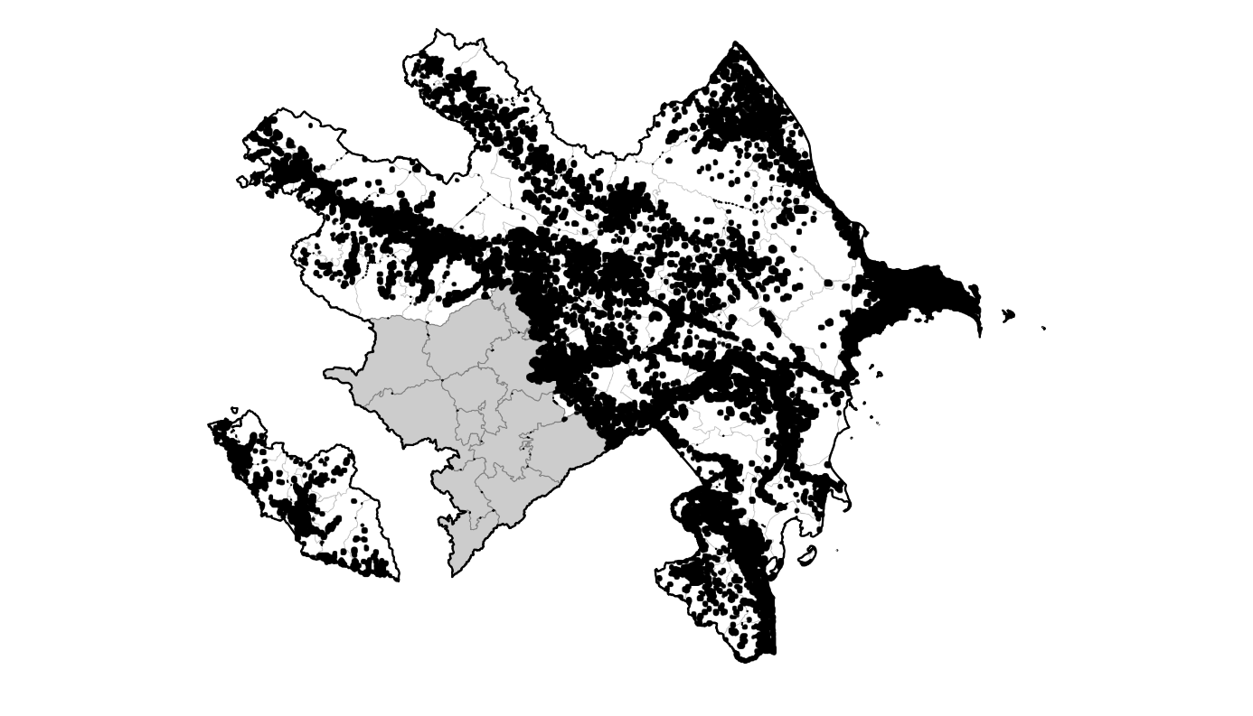
Figure 6: Spatial Distribution of Pixels in the Final Analysis Sample
Source: Author's calculations based on VIIRS nighttime light data and the final analysis sample.
Notes: Each point represents a unique nighttime light pixel included in the final empirical sample. Grey areas indicate conflict-affected districts excluded from the analysis.

Descriptive Statistics
Table 3 presents descriptive statistics for the main variables used in the empirical analysis. The statistics are based on the final analysis sample described in Section 3.6 and summarize the distribution of nighttime light intensity, the real Brent oil price, and the main spatial characteristics of the nighttime light pixels. As the variables vary at different levels, nighttime light statistics are calculated using pixel-year observations, oil-price statistics using annual observations, and time-invariant spatial characteristics using unique pixels.
Table 3: Descriptive Statistics
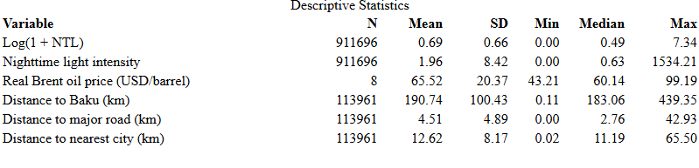
Source: Author's calculations based on the final analysis sample.
Notes: NTL statistics are based on pixel-year observations. Oil-price statistics are based on annual observations, while time-invariant spatial variables are summarized across unique pixels. Distance variables are reported in kilometers for ease of interpretation. In the empirical analysis, distance variables are measured in meters and transformed using $ln\left(1+distance\right).$

Nighttime light intensity exhibits a strongly right-skewed distribution, with a mean of 1.96 and a median of 0.63, while a small number of observations reach substantially higher radiance levels. The logarithmic transformation considerably compresses this upper tail: the mean of $ln\left(1+NTL\right)$ is 0.69, with a standard deviation of 0.66. The log-transformed measure is therefore used as the main dependent variable in the empirical analysis.

Empirical Methodology
This chapter presents the empirical methodology used to examine whether the relationship between international oil-price fluctuations and local economic activity varies with geographical distance from Baku. The analysis combines temporal variation in real Brent oil prices with spatial variation across nighttime light pixels. The chapter first introduces the baseline empirical specification and then discusses the fixed-effects structure and identification strategy. Finally, the baseline model is extended by incorporating additional spatial controls related to settlement characteristics and road accessibility.

Empirical Strategy and Baseline Specification
The baseline empirical specification exploits the interaction between annual variation in the real Brent oil price and the time-invariant geographical distance of each nighttime light pixel from Baku. The model is specified as follows:
$$\ln\left(1+NTL_{it})=β\left[OilPrice_{t}×\ln\left(1+DistanceBaku_{i}\right)\right]+α_{r}+λ_{t}+ε_{\left(it\right)}\right.$$ | (4.1)
In this specification, $NTL_{it}$ denotes nighttime light intensity for pixel $i$ in year $t$, and the dependent variable is transformed as $\ln\left(1+NTL_{it}\right).$ This transformation retains observations with zero radiance while reducing the influence of the strongly right-skewed distribution of nighttime light intensity. $OilPrice_{t}$ represents the annual real Brent crude oil price, while $DistanceBaku_{i}$ measures the geographical distance of pixel $i$ from Baku in meters. The distance variable is also transformed using $\ln\left(1+DistanceBaku_{i}\right).$
The coefficient of primary interest is $β$. It captures how the relationship between oil-price fluctuations and nighttime light intensity differs according to a pixel's distance from Baku. A negative coefficient indicates that, when oil prices are higher, nighttime light intensity is relatively lower in locations farther from Baku compared with locations closer to Baku. A positive coefficient indicates the opposite spatial pattern. Thus, $β$ captures a relative spatial relationship rather than the overall association between oil prices and economic activity in Azerbaijan.
The specification includes district FE, $α_{r}$ and year FE, $λ_{t}$, while $ε_{it}$ denotes the error term. The identification strategy, the role of the FE, and the treatment of standard errors are discussed in the following section.

Fixed Effects, Identification and Inference
The baseline specification includes both district and year FE. District FE control for characteristics that differ across districts but remain relatively constant over the sample period. These may include persistent geographical conditions, differences in location, or other time-invariant district characteristics that could be related to nighttime light intensity. As a result, the estimated relationship is not driven simply by permanent differences in economic activity across districts.
Year FE account for factors that affect all locations in Azerbaijan in a given year. These may include nationwide economic conditions, macroeconomic developments, or other common annual shocks. Since the Brent oil price varies only over time and takes the same value for all pixels in a given year, its direct effect is absorbed by the year FE. Similarly, distance from Baku is constant over time for each pixel and is therefore not the main source of variation of interest on its own. The empirical analysis instead focuses on the interaction between oil prices and distance from Baku.
Identification of the coefficient of interest comes from combining the annual variation in oil prices with the spatial variation in distance from Baku. In other words, the model examines whether changes in nighttime light intensity associated with different oil-price conditions vary systematically between locations that are closer to and farther from Baku. This allows the analysis to focus on the spatially heterogeneous relationship between oil-price fluctuations and local economic activity rather than on the overall effect of oil prices on Azerbaijan.

Standard errors are clustered at the district level. This allows the error terms of pixels located within the same district to be correlated with each other, both because nearby locations may be exposed to similar local conditions and because several observations belong to the same administrative area. Clustering at the district level therefore provides inference that accounts for this within-district dependence.
Overall, the specification uses variation across both time and space: oil prices provide the temporal variation, while distance from Baku provides the spatial variation. The interaction of these two variables is the main source of identifying variation used to examine whether the relationship between oil-price fluctuations and nighttime light intensity differs across locations in Azerbaijan.

Extended Specification and Spatial Controls
The baseline model is extended by adding a small set of spatial controls that capture differences in local accessibility. In particular, nighttime light intensity may differ systematically between locations that are close to urban centers and locations that are relatively remote. A similar pattern may exist with respect to access to the main road network. To account for these differences without including a large number of closely related spatial variables, the extended specification includes one city-related measure and one road-related measure.
The city-related control is the distance from each nighttime light pixel to the nearest settlement classified as a city. The settlement dataset distinguishes between villages, towns, and cities, and only observations classified as cities are used for this measure. For each pixel, the nearest city is identified and the corresponding straight-line distance is calculated. The road-related control is the distance to the nearest major road, using the major-road category defined in Section 3.2. Both distances are calculated in meters and are constant over time for each pixel.

As with distance from Baku, the two control variables are transformed using the natural logarithm of one plus distance. This reduces the influence of very large distances and allows the variables to enter the specification in a comparable form. The extended model is written as:

$$\ln\left(1+NTL_{it})=β\left[OilPrice_{t}×\ln\left(1+DistanceBaku_{i}\right)\right]+γ_{1}\ln\left(1+DistanceCity_{i}\right)+γ_{2}\ln\left(1+DistanceMajorRoad_{i}\right)+α_{r}+λ_{t}+ε_{\left(it\right)}\right\}$$ | (4.2)

The coefficient of primary interest remains $β$. The additional spatial variables are not intended to replace the baseline specification, but rather to examine whether the estimated oil-price–distance relationship remains similar after accounting for basic differences in urban proximity and road accessibility. In the empirical implementation, the same district and year FE are retained and standard errors continue to be clustered at the district level.
Several related measures of local accessibility are available, including distance to secondary roads, distance to the nearest settlement, and settlement type. However, including several closely related spatial variables simultaneously would make the specification unnecessarily complex and could make the individual coefficients more difficult to interpret. The extended specification therefore follows a parsimonious approach and includes one city-related measure and one road-related measure: distance to the nearest city and distance to the nearest major road.

Limitations of the Spatial Controls
An important limitation of the spatial controls is that the available road and settlement datasets do not provide a complete historical description of these characteristics for every year between 2013 and 2020. The empirical analysis therefore treats both road accessibility and proximity to cities as time-invariant characteristics of each pixel. This is useful for describing the spatial environment of a location, but it also limits how the estimated coefficients on these variables can be interpreted.
Ideally, spatial controls would represent characteristics that were already determined before the beginning of the analysis period. For the road network, however, the available data provide a recent snapshot of the network and do not contain systematic information on the construction or opening year of each road segment. It is therefore not possible to verify that every road included in the dataset was already present at the beginning of the sample period. For this reason, distance to the nearest major road is used as a spatial accessibility control rather than as a variable with a direct causal interpretation.
A similar issue applies to the settlement data. The dataset provides the location and administrative classification of settlements, but it does not provide an annual historical classification for the full sample period. Distance to the nearest city is therefore also treated as a fixed spatial characteristic. The variable is intended to distinguish pixels located close to larger urban centers from more remote pixels, rather than to estimate the causal effect of city proximity on nighttime light intensity.
These limitations are particularly relevant because road development and settlement patterns may themselves be related to economic development. If some of these characteristics changed during the sample period, controlling for them could potentially capture part of the same economic processes reflected in nighttime lights. For this reason, the specification without these additional controls remains the baseline model, while the extended specification is used as an additional check on whether the main interaction between oil prices and distance from Baku is sensitive to basic spatial characteristics.

Robustness Checks
Two robustness checks are carried out to examine whether the main result is sensitive to the composition of the sample and to the choice of spatial controls. The coefficient of interest remains the interaction between the real Brent oil price and distance from Baku. The purpose of these checks is therefore not to introduce a new empirical strategy, but to assess whether the estimated spatial relationship remains similar under alternative specifications.
The first robustness check excludes all nighttime light pixels located within the administrative districts of Baku. This is relevant because Baku contains observations located very close to the reference point used for the distance measure and also represents the most highly urbanized part of the country. These observations could therefore have a relatively strong influence on the estimated interaction between oil prices and distance from Baku. After removing the Baku pixels, the extended specification is re-estimated using only observations outside the capital. Importantly, distance to Baku is still retained for all remaining pixels. The interaction term therefore continues to measure whether the relationship between oil-price fluctuations and nighttime light intensity varies with geographical distance from Baku, but without using observations located within Baku itself. This provides a direct test of whether the main result is driven primarily by the capital.
The second robustness check considers an alternative way of controlling for the local settlement structure. In the extended specification, spatial accessibility is represented by distance to the nearest city and distance to the nearest major road. As an alternative, these continuous controls are replaced by the type of the nearest administrative settlement. Each pixel is assigned to the settlement located closest to it, and the settlement is classified as a village, town, or city according to the administrative settlement dataset described in Section 3.4. Settlement type is then included in the regression as a categorical variable.
This alternative measure captures a different aspect of the spatial environment. The main extended specification measures how far a pixel is located from a city and from a major road, whereas the alternative specification focuses on the type of settlement that is closest to the pixel. It should be noted that this variable does not measure the actual distance to the nearest settlement. For example, two pixels may both have a city as their nearest settlement even though one is located much closer to that city than the other. The variable is therefore used as an alternative characterization of local settlement structure rather than as a direct measure of accessibility.
The settlement-type coefficients themselves are not interpreted as causal effects. As discussed in Section 4.4, the available settlement information does not provide a complete historical classification for every year of the sample period. The main interest in this specification is instead whether the estimated coefficient on the interaction between oil prices and distance from Baku is sensitive to replacing the continuous city and road controls with a simpler categorical measure of the nearest settlement environment.
Taken together, the two robustness checks address different concerns. Excluding Baku tests whether the main relationship is disproportionately influenced by observations located in the capital, while the alternative settlement specification tests whether the result depends strongly on the particular spatial controls included in the extended model. The results of these robustness checks are presented together with the main regression results in the following chapter.

Empirical Results
This chapter presents the empirical results based on the specifications introduced in Chapter 4. The analysis first reports the baseline relationship between real Brent oil prices, distance from Baku, and nighttime light intensity. It then examines whether this relationship changes after controlling for proximity to cities and major roads. Finally, the robustness checks assess the sensitivity of the results to the exclusion of Baku and to an alternative measure of local settlement characteristics.

Baseline and Extended Results
Table 4 presents the results of the baseline and extended specifications, together with the two robustness checks discussed in Section 4.5. Column (1) reports the baseline model, while Column (2) extends the model by adding distance to the nearest city and distance to the nearest major road. Columns (3) and (4) report the robustness specifications, which are discussed separately in Section 5.2.
Column (1) shows the results of the baseline specification. The interaction between the real Brent oil price and log distance from Baku is negative and statistically significant at the 1 percent level. The estimated coefficient is −0.00235, with a clustered standard error of 0.00074. The negative coefficient indicates that the relationship between oil prices and nighttime light intensity becomes less favorable as distance from Baku increases. Put differently, under higher oil-price conditions, locations farther from Baku show a relatively weaker nighttime-light response than locations closer to the capital. The interaction coefficient should be interpreted according to the units of the variables used in the model. The real Brent oil price is measured in USD per barrel, while distance from Baku enters the regression in logarithmic form. Therefore, the coefficient of −0.00235 implies that a one-dollar increase in the real Brent oil price is associated with a 0.00235 log-point lower nighttime-light response when log distance from Baku increases by one unit.

Table 4: Estimation Results
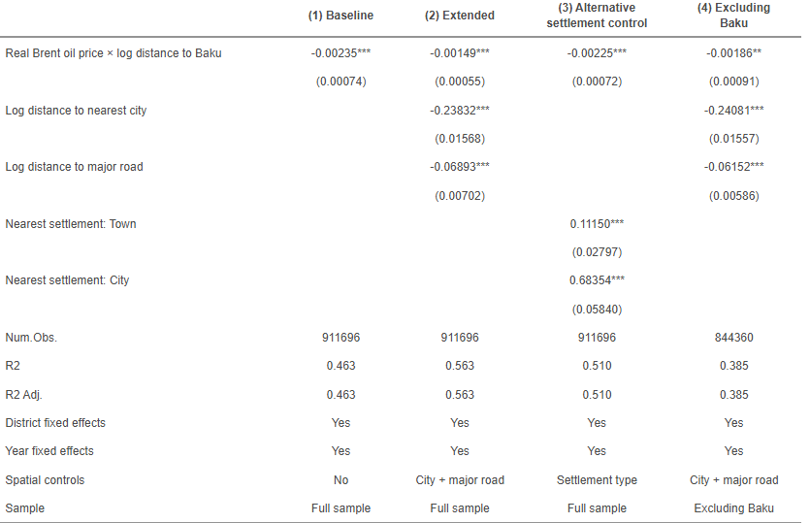
Notes: The dependent variable is the natural logarithm of one plus nighttime light intensity, $ln\left(1+NTL\right)$. Clustered standard errors at the district level are reported in parentheses. All specifications include district and year FE. Column (2) includes log distance to the nearest city and log distance to the nearest major road as spatial controls. In Column (3), village is the reference category for the nearest-settlement type. Column (4) excludes all pixels located within the administrative districts of Baku. * $p<0.10$, ** $p<0.05$, *** $p<0.01$.

The coefficient captures a difference in the oil-price relationship across locations rather than the overall effect of oil prices on nighttime light intensity. The direct oil-price term itself is absorbed by the year FE.
Column (2) adds the two spatial controls introduced in Section 4.3: log distance to the nearest city and log distance to the nearest major road. After including these variables, the interaction between the real Brent oil price and distance from Baku remains negative and statistically significant at the 1 percent level. The estimated coefficient decreases in absolute magnitude from −0.00235 in the baseline model to −0.00149 in the extended specification.
This change suggests that differences in urban proximity and road accessibility account for part of the spatial variation captured by the baseline specification. However, the interaction remains negative and statistically significant after these characteristics are taken into account. The main relationship between oil-price fluctuations and distance from Baku is therefore still present in the extended model.
The additional spatial controls also show clear associations with nighttime light intensity. The coefficient on log distance to the nearest city is −0.23832 and statistically significant at the 1 percent level. This indicates that pixels located farther from cities tend to have lower nighttime light intensity, conditional on the other variables included in the model. The coefficient on log distance to the nearest major road is also negative and statistically significant, with an estimate of −0.06893. Thus, pixels located farther from the major road network are also associated with lower levels of nighttime light intensity.
These coefficients should not be interpreted as causal effects of city or road proximity. As discussed in Section 4.4, the available settlement and road datasets do not provide complete historical information for the full sample period. The variables are therefore used as time-invariant spatial controls, and their coefficients describe conditional associations with nighttime light intensity.
The reported $R^{2}$ increases from 0.463 in the baseline model to 0.563 in the extended specification. Since both models use the same 911,696 pixel-year observations and the same district and year FE, the higher $R^{2}$ reflects the additional variation in nighttime light intensity accounted for by the two spatial controls. At the same time, the coefficient of primary interest remains negative and statistically significant.
Overall, Columns (1) and (2) show a consistent spatial pattern. Higher oil prices are associated with a relatively weaker nighttime-light response at greater distances from Baku, and this relationship remains statistically significant after controlling for proximity to cities and major roads. Columns (3) and (4) of Table 4 provide additional robustness checks, which are discussed in Section 5.2.

Robustness Checks
Columns (3) and (4) of Table 4 present two robustness checks designed to examine whether the main result is sensitive to the choice of spatial controls and to the inclusion of observations located within Baku. In both cases, the interaction between the real Brent oil price and log distance from Baku remains the main coefficient of interest.
Column (3) replaces the continuous measures of distance to the nearest city and distance to the nearest major road with the type of the nearest settlement. The interaction coefficient remains negative and statistically significant at the 1 percent level, with an estimated coefficient of approximately −0.00225. This is close in direction and magnitude to the baseline estimate and indicates that the main spatial relationship does not depend on the specific continuous accessibility controls used in the extended specification.
The settlement-type coefficients are also statistically significant. Compared with pixels whose nearest settlement is a village, pixels whose nearest settlement is a town or a city tend to have higher nighttime light intensity. The positive coefficient is particularly large for pixels located closest to a city. These results are consistent with the general spatial pattern found in the extended model, where greater distance from cities is negatively associated with nighttime light intensity. However, as discussed in Section 4.4, these coefficients are interpreted as spatial associations rather than causal effects.
Column (4) provides a second robustness check by excluding all pixels located within the administrative districts of Baku. This removes observations from the capital while retaining the distance to Baku for all remaining locations. The interaction coefficient remains negative, with an estimate of approximately −0.00186, and remains statistically significant at the 5 percent level. Compared with the full-sample extended specification, the standard error increases, indicating that the estimate becomes less precise after Baku is excluded. Nevertheless, the sign and general magnitude of the coefficient remain similar.
Figure 7 summarizes the estimated oil-price–distance interaction across the baseline, extended, and robustness specifications. The coefficient remains negative across all four models, while the confidence interval becomes wider when Baku is excluded from the sample.
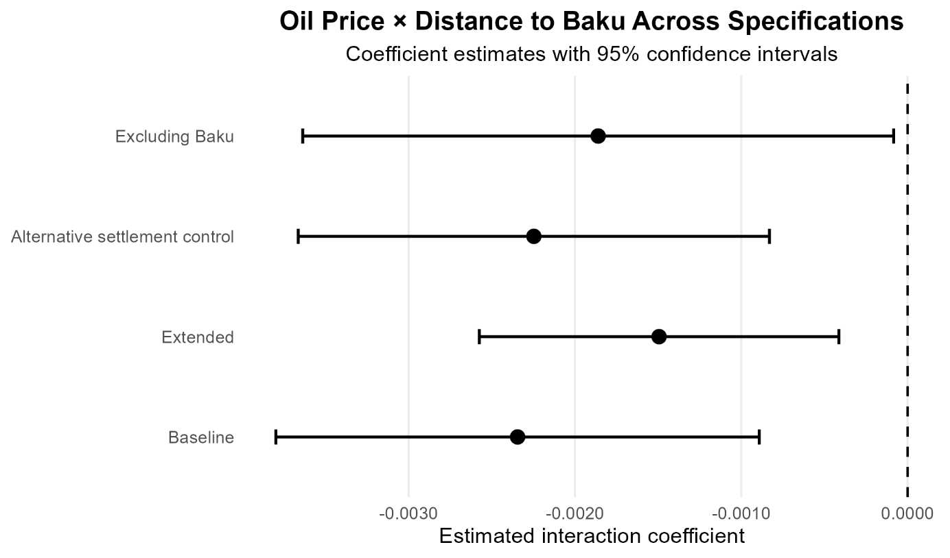
Figure 7: Estimated Oil Price × Distance to Baku Interaction Across Specifications
Source: Author's calculations based on the final analysis sample
Notes: Points represent coefficient estimates for the interaction between the real Brent oil price and log distance from Baku. Horizontal lines represent 95% confidence intervals based on standard errors clustered at the district level. The dashed vertical line indicates a coefficient of zero.
Taken together, the two robustness checks support the stability of the main empirical pattern. The negative interaction between oil prices and distance from Baku remains present when the spatial controls are defined differently and when observations located within Baku are removed from the sample. At the same time, the lower precision of the estimate in the Baku-excluded specification suggests that the strength of the relationship should be interpreted with some caution.

Discussion of the Main Findings
Taken together, the empirical results point to a consistent spatial pattern in the relationship between international oil prices and local economic activity in Azerbaijan. Across the baseline, extended, and robustness specifications, the interaction between the real Brent oil price and distance from Baku remains negative. This suggests that locations farther from Baku tend to show a relatively weaker nighttime-light response during periods of higher oil prices compared with locations closer to the capital.
This finding is consistent with the idea that the economic effects associated with oil-price fluctuations may not be distributed evenly across space. Baku represents the main economic and administrative center of Azerbaijan, and economic activity related directly or indirectly to the oil sector is strongly concentrated around the capital. If increases in oil revenues are transmitted through government expenditure, investment, employment, consumption, or other local economic channels, locations closer to Baku may be better positioned to benefit from these changes. The results are therefore consistent with a spatially uneven transmission of oil-related economic conditions.
At the same time, the estimates do not identify the specific mechanism through which this spatial pattern operates. Nighttime light intensity captures changes in local economic activity, but it does not distinguish whether these changes originate from public investment, private-sector activity, household consumption, construction, or other channels. The estimated interaction should therefore be interpreted as evidence of geographical heterogeneity in the relationship between oil prices and local economic activity rather than as direct evidence of a particular transmission mechanism.
The results for the spatial controls provide additional information about the geographical distribution of economic activity. Pixels located farther from cities and major roads generally exhibit lower nighttime light intensity. This is consistent with economic activity being more concentrated in locations with better urban and transport accessibility. However, these relationships are not interpreted causally, since the available road and settlement datasets do not provide complete historical information for the entire sample period.
The robustness checks strengthen the interpretation of the main spatial pattern. The interaction remains negative when the continuous city and road controls are replaced by the type of the nearest settlement. It also remains negative after all pixels located within Baku are removed from the sample. The latter result is particularly relevant because it indicates that the estimated relationship is not generated solely by the strong concentration of nighttime lights within the capital. Nevertheless, the lower precision of the estimate after excluding Baku suggests that the magnitude of the relationship should be interpreted cautiously.
The findings also relate to the broader literature on spatial accessibility and local economic activity. Previous studies have shown that geographical accessibility can influence how economic shocks and market opportunities are transmitted across space. In this respect, the results for Azerbaijan suggest that proximity to the country's main economic center may be an important dimension of how oil-related economic conditions are reflected locally. At the same time, the mechanism differs from settings where higher oil prices operate mainly through transportation costs. In the Azerbaijani context, higher oil prices are closely associated with changes in national oil revenues and broader economic conditions.
Overall, the empirical findings provide an answer to the main research question of the thesis: the relationship between international oil-price fluctuations and local economic activity appears to vary systematically with geographical distance from Baku. Higher oil-price conditions are associated with relatively stronger nighttime-light outcomes in locations closer to Baku and weaker outcomes in more distant locations. The results therefore suggest that geographical proximity to the country's main economic center may be an important dimension of how oil-related economic conditions are reflected across space.
The main contribution of the analysis is to document this spatial heterogeneity within Azerbaijan using high-resolution nighttime light data. Rather than focusing only on national or regional aggregates, the pixel-level approach makes it possible to examine how the relationship between oil-price fluctuations and local economic activity varies continuously with geographical distance from Baku.

Conclusion
This thesis examines whether the relationship between international oil-price fluctuations and local economic activity differs across locations in Azerbaijan. The main focus is on geographical distance from Baku, which is the country’s main economic center. Local economic activity is measured using nighttime light intensity at the pixel level, while annual real Brent oil prices are used to capture changes in international oil-market conditions. The analysis covers the period from 2013 to 2020.
The empirical approach combines changes in oil prices over time with differences in distance from Baku across locations. The main specification includes district and year FE and focuses on the interaction between the real Brent oil price and distance from Baku. An extended specification also controls for distance to the nearest city and distance to the nearest major road in order to account for basic differences in local accessibility.
The results show a clear and consistent spatial pattern. The interaction between the real Brent oil price and distance from Baku is negative and statistically significant in the baseline model. The coefficient remains negative and significant after adding the city and road controls, although its magnitude becomes somewhat smaller. This suggests that differences in urban and road accessibility explain part of the spatial variation in nighttime light intensity, but they do not fully explain the relationship between oil-price fluctuations and distance from Baku.
In practical terms, the results indicate that periods of higher oil prices are associated with relatively stronger nighttime-light outcomes in locations closer to Baku than in locations farther away. This should not be interpreted as the overall effect of oil prices on the Azerbaijani economy. Rather, the estimates show that the relationship between oil-price conditions and local economic activity differs across space.

The spatial controls also show that pixels located farther from cities and major roads generally have lower nighttime light intensity. These findings are consistent with economic activity being more concentrated around urban centers and locations with better transport access. However, these coefficients are not interpreted as causal effects, since the available road and settlement data do not provide complete historical information for the whole 2013–2020 period.
The robustness checks provide additional support for the main result. First, replacing the continuous city and road controls with the type of the nearest settlement does not change the general pattern: the oil-price and distance interaction remains negative and statistically significant. Second, the result also remains negative when pixels located within Baku are excluded from the sample. The estimate becomes less precise in this case, but the main relationship is still present. These checks suggest that the result is not driven only by the concentration of nighttime lights in Baku or by one particular choice of spatial controls.
The main contribution of this thesis is to show that the relationship between international oil-price fluctuations and local economic activity within Azerbaijan is spatially uneven. Using high-resolution nighttime light data makes it possible to study these differences at a much finer geographical level than would be possible with conventional regional economic statistics. In this way, the analysis provides evidence that proximity to Baku is an important dimension of how oil-related economic conditions are reflected across different parts of the country.
There are also several limitations. Nighttime light intensity is only a proxy for economic activity and cannot capture every type of economic change. In addition, the road and settlement datasets describe the available spatial structure but do not provide complete historical information for every year of the sample. The analysis also cannot identify the exact channel behind the estimated spatial pattern. For example, it cannot determine whether the differences arise mainly through public spending, private investment, employment, household consumption, construction, or other mechanisms. Finally, the analysis covers only eight years, which limits the amount of time variation available in international oil prices.
Future research could examine these mechanisms more directly by combining nighttime light data with more detailed local information on public spending, investment, employment, firms, or household activity. Historical road-network data would also be useful for separating pre-existing transport accessibility from infrastructure developments that may themselves respond to economic conditions. A longer time period could additionally provide more variation in international oil prices and allow the spatial relationship to be studied across different oil-price cycles.
Overall, the findings suggest that oil-related economic conditions are not reflected equally across space in Azerbaijan. Locations closer to Baku tend to show a relatively stronger nighttime-light response during periods of higher oil prices, while the response becomes weaker with greater distance from the capital. Although the analysis does not identify the exact mechanism behind this pattern, it shows that geography matters when studying how aggregate economic changes are reflected at the local level in a resource-dependent economy.

References
- Baku Research Institute, 2025. [Online]
Available at: https://bakuresearchinstitute.org/en/the-contribution-of-the-regions-to-the-national-economy-a-comparison-between-azerbaijan-and-neighboring-countries/
[Accessed 23 August 2026].
- Caselli, F. & Michaels, G., 2013. Do Oil Windfalls Improve Living Standards? Evidence from Brazil. American Economic Journal: Applied Economics, 5(1), p. 208–238.
- Chiovelli, G., Michalopoulos, S., Papaioannou, E. & Regan, T., 2026. Illuminating the Global South. The Economic Journal, p. 1–32.
- Donaldson, D., 2018. Railroads of the Raj: Estimating the Impact of Transportation Infrastructure. American Economic Review, 108(4–5), p. 899–934.
- Elvidge, C. D. et al., 2021. Annual Time Series of Global VIIRS Nighttime Lights Derived from Monthly Averages: 2012 to 2019. Remote Sensing, 13(5), p. 922.
- Google Earth Engine, n.d. VIIRS Nighttime Day/Night Annual Band Composites V2.1. [Online]
Available at: https://developers.google.com/earth-engine/datasets/catalog/NOAA_VIIRS_DNB_ANNUAL_V21
[Accessed 5 September 2026].
- Hajiyeva, G. et al., 2025. The role of oil and gas industry in Azerbaijan’s economic development: investment trends and global context. Polityka Energetyczna – Energy Policy Journal, 28(2), p. 55–72.
- Henderson, J. V., Storeygard, A. & Weil, D. N., 2012. Measuring Economic Growth from Outer Space. American Economic Review, 102(2), p. 994–1028.
- Ibadoghlu, G., 2026. Energy, Power, and Repression: Political Economy Insights from Azerbaijan, Washington, D.C.: s.n.
- Ishak, P. W. & Méon, P.-G., 2023. A Resource-Rich Neighbor Is a Misfortune: The Spatial Distribution of the Resource Curse in Brazil. Economic Development and Cultural Change, 71(4), p. 1213–1247.
- OpenStreetMap contributors, 2026. Roads of Azerbaijan. [Online]
Available at: https://data.humdata.org/dataset/hotosm_aze_roads
[Accessed 27 April 2026].
- REIS – Digital Ecology Information System, 2025. Cities and administrative territorial units of Azerbaijan. [Online]
Available at: https://opendata.az/en/@azerbaycan-respublikasinin-ekologiya-ve-tebii-servetler-nazirliyi/azerbaycanin-seherleri-ve-inzibati-erazi-vahidleri
[Accessed 15 September 2026].
- State Oil Fund of the Republic of Azerbaijan (SOFAZ), 2024. Annual Report 2024, s.l.: State Oil Fund of the Republic of Azerbaijan.
- Storeygard, A., 2016. Farther on down the Road: Transport Costs, Trade and Urban Growth in Sub-Saharan Africa. Review of Economic Studies, 83(3), p. 1263–1295.
- U.S. Energy Information Administration, 2019. Background Reference: Azerbaijan, Washington, DC: U.S. Energy Information Administration.
- World Bank, 2011. Azerbaijan: Building Assets and Promoting Self Reliance: The Livelihoods of Internally Displaced Persons, Washington, DC: World Bank.
- World Bank, 2022. The Republic of Azerbaijan: Systematic Country Diagnostic Update, Washington, DC: World Bank.
- World Bank, 2026. Commodity Markets. [Online]
Available at: https://www.worldbank.org/en/research/commodity-markets
[Accessed 15 June 2026].

Selbständigkeitserklärung

Ich erkläre hiermit ehrenwörtlich, dass ich die vorliegende Arbeit selbstständig und ohne Benutzung anderer als der angegebenen Hilfsmittel angefertigt habe. Die aus fremden Quellen direkt oder indirekt übernommenen Gedanken sind als solche kenntlich gemacht. Die Arbeit wurde bisher in gleicher oder ähnlicher Form keiner anderen Prüfungsbehörde vorgelegt und noch nicht veröffentlicht. Ich bin mir bewusst, dass eine unwahre Erklärung rechtliche Folgen haben wird.
Ich erkläre mich damit einverstanden, dass die Arbeit mit Hilfe eines Plagiatserkennungsdienstes auf enthaltene Plagiate untersucht wird.

Place, date
Dresden, 05.10.2026

Signature
Elvin Mammadov

Einverständniserklärung FIS

Hiermit willige ich freiwillig in die Erfassung folgender personenbezogenen Daten im Forschungsinformationssystem der TU Dresden sowie in die weltweite Veröffentlichung dieser Daten durch die TU Dresden im Internet oder/und in Druckschriften ein: Autor, Betreuer, Jahr, Titel, Abstract, Art der Abschlussarbeit, zugeordnete Forschungsschwerpunkte bzw. -projekte.
Mir ist bekannt, dass ich diese Einwilligung ohne Rechtsfolgen verweigern kann. Mir ist darüber hinaus bekannt, dass ich diese Einwilligung jederzeit formlos und ohne Angabe von Gründen widerrufen kann. In diesem Falle werden o.g. Daten unverzüglich aus dem Forschungsinformationssystem gelöscht. Die TU Dresden wird in diesem Fall dafür Sorge tragen, soweit es von der TU Dresden nach Veröffentlichung im Internet oder in Druckschriften beeinflussbar ist, dass auch die veröffentlichten Daten gelöscht werden.

Dresden, 05.10.2026
Signature: ____________________
Elvin Mammadov

